Creating a new Partner Portal Site for [Site_Code] – Support.Fluke.com

File Server Directory Structure Configuration and Permissions

In this document, the [Site_Code] is a placeholder supplied by the developer. Substitute the [site_code] place holder with the directory name provided for by the developer.

Example:

If the site code was “DHI-Sales” replace the reference \Extranet\[Site_Code] with DHI-Sales; or \ExtranetDHI-Sales.

Create the following directory structure (see image) on the File Server first (test and then production) under the main \Extranet root.

\Extranet\[Site_Code]

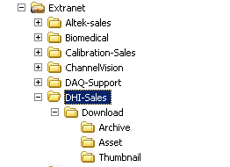

Set Security permissions for the root directory \[Site_Code] and all of the subdirectories under \[Site_Code] to the standard configuration (you can use \FIND-Sales as an example. The most important aspect of the security configuration is the addition of the !SupportExtranet service account (name on DEV only) and its permissions to allow uploading (write) of files from the web server (FileUpEE).

The corresponding accounts on TEST and FLK are data\fnet.testassets and data\fnet.assets respectively.

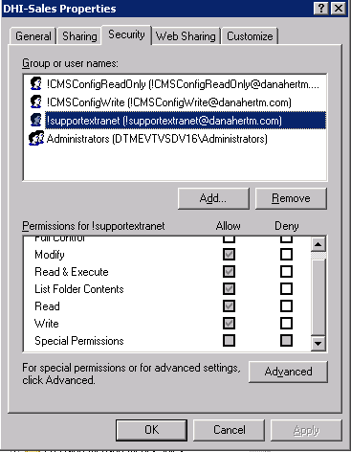

Set all the subdirectories under the parent \[Site_Code] directory to inherit the parent security settings.

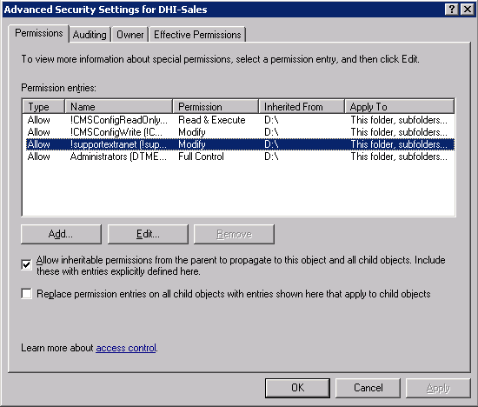

Web Server Directory Structure Configuration and Permissions

Create the following directory structure (see image) on the Web Server (test and then production) under the main \Extranet root.

\Extranet\[Site_Code]

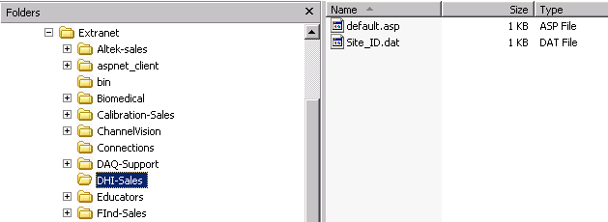

Set Security permissions for the root directory \[Site_Code] to the standard configuration, (you can use \FIND-Sales as an example. The most important aspect of the security configuration is the addition of the !SupportExtranet service account and its permissions to allow uploading (write) of files to the web server and then to the file server using (FileUpEE)

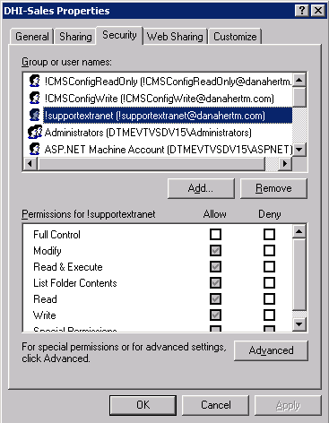

Copy the two files Site_ID.dat, Default.asp and the directory \Database from the DEV server DTMEVTVSD15 under the \Extranet\[Site_Code] directory to the corresponding directory \Extranet\[Site_Code] on the test and production web servers (not file server).

Web Server IIS Configuration

Open Internet Services Manager on the web server, under (local computer), open up the Web Sites folder, expand the Extranet site, and locate the [Site_Code] folder.

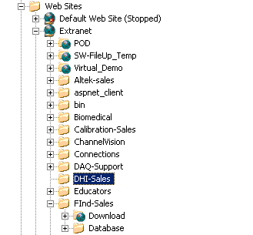

Right click on this folder and select New | Virtual Directory…

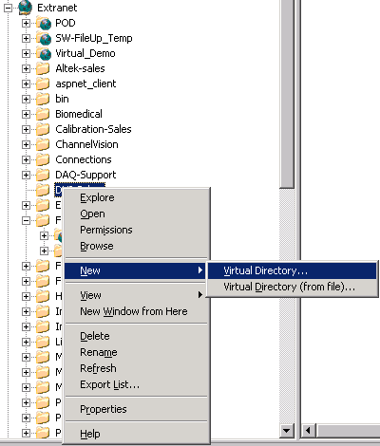

The Virtual Directory Wizard dialog will appear.

For the alias, type in “Download”

When you browse for the path, you will actually be specifying a directory on the file server.

On the DEV file server, this path is the following:

\\dtmevtvsdv16\extranet$\[Site_Code]\download

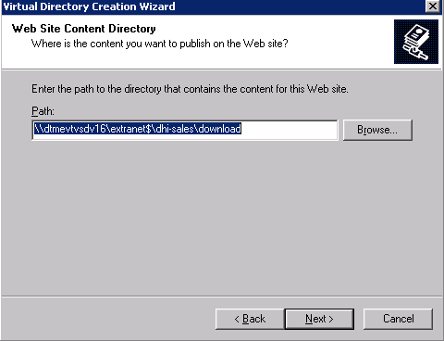

You can use the \Find-Sales virtual directory “Download” as an example of how to construct the Path to include the proper server names for the test and production tier. [Next > ]

Security Credentials

Uncheck the “Always use authenticated user’s credentials…” checkbox

Either browse for or enter in the fully qualified User Name and password (maybe same or different for test and production tiers), for the !SupportExtranet service account.

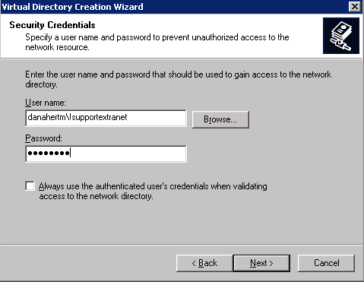

[ Next > ]

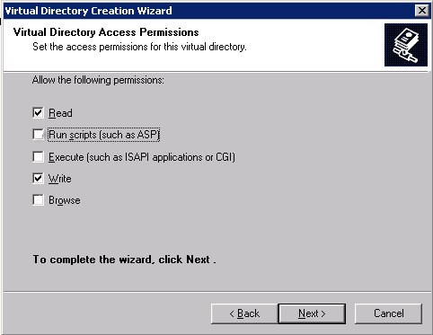

Check the Read, and Write checkboxes [ Next > ], [ Finish ]

Right click on the new virtual directory \extranet\[Site_Code]\download and select properties.

The Virtual Directory dialog box should look similar to the screen capture below:

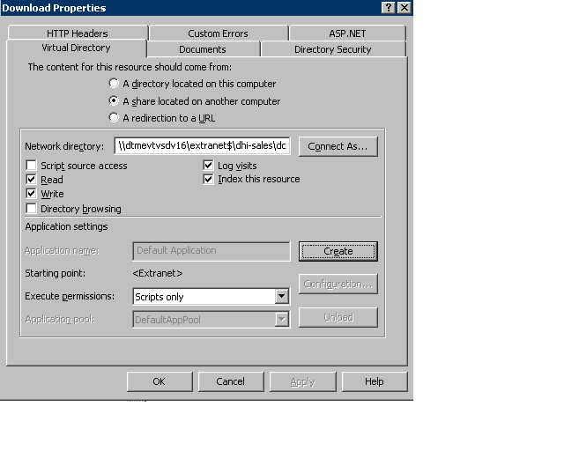

Under the Directory Security tab, click on “Authenticated and access control” [ EDIT ] and verify the following:

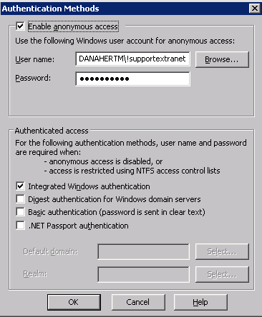

In IIS, Stop and Restart the Extranet web site. Submit a RTP ticket for CAB approval to execute the IIS restart on the production server.

Close IIS

The above example is based on the DTMEVTVSD15 web server and DTMEVTVSD16 file server configuration. Since this author does not have visibility into the test and production tiers of the Support.Fluke.com extranet servers there are some configuration differences which are documented. See Andrew Bui for FNET 2.0 documentation, specifically the document “Configure Web and File Server for Test/Production Environments”.

This same documentation can be used for the setup and configuration of any new Partner Portal websites. Just substitute the sites root name with the new site root name for all occurrences of \[Site_Code] in this document.

Kelly Whitlock

